Our web app

Home page

Header

header consists of a logo at the right top and all navigations through out the application as buttons or anchor tags text (which looks good at design side) which on clicked navigates user to that particular page.

Main content:

Right below the header I am planning to implement a scrolling of images when clicked will navigate to that particular part (note: these can be a individual video or a webpage or anything that has url and when clicked we will have redirection to that url)

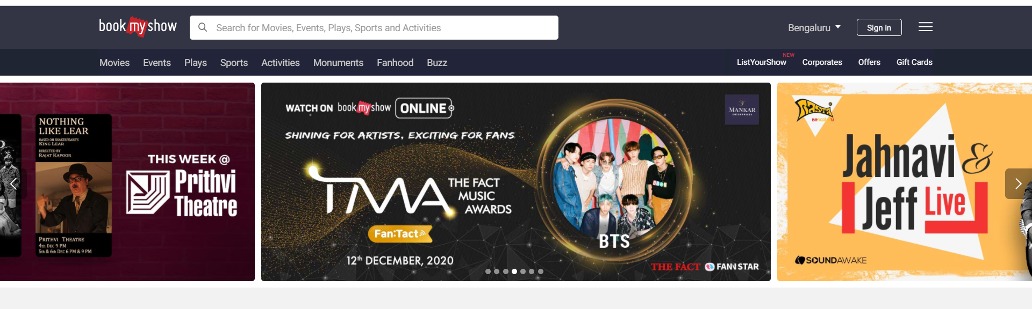

Next main content:

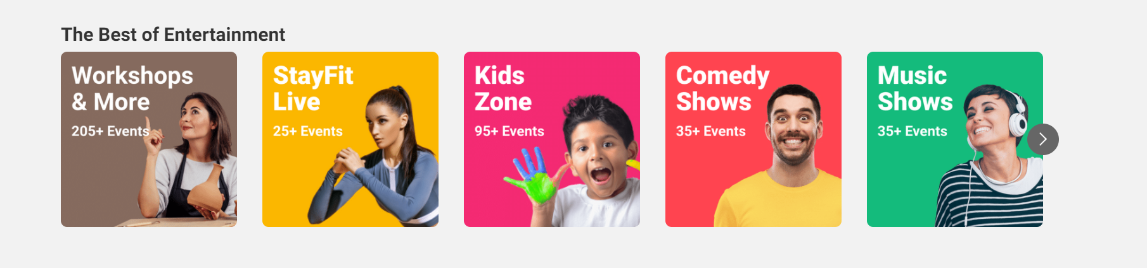

Then after that we will have pics of certain sections like in the pic above we will also have texts below it when clicked we will redirect to that page.

Ex: featured videos

Top viewed videos

Coming soon

Snacks section

Tiffin section

Next sub main content:

Still not decided can have or implements or suggest ones own idea

Footer

Footer will have button to go to top of page

And also all the web app info like contact us or developers info like all rights reserved or developed by phigters etc.,.

Note: I am very much inspired by bookmyshow website design. Its nice minimal and well organized and makes users to choose anything in home page itself.

Content page

Note : I suggest we keep our design minimal and refine so that everything in our web app is related and same.

So for the content page we simply have the same header as in home page and we have heading of the page like (eg. Featured, coming soon etc.,) and then below them we have our content

Our content involve a pic and heading below it.

Like this 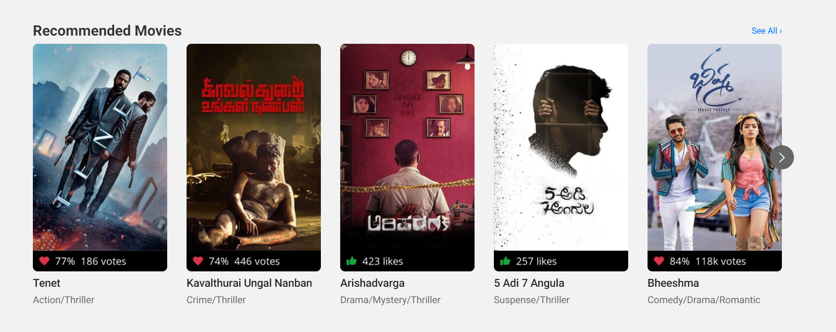

When clicked we will directly redirect to that youtube url . no big deal here its <a href=”#”> tag .

Same goes for all other content pages but for coming soon pages we will not redirect to youtube url we just keep the pictures unclickable its just for viewing.

Ask us page

We will have a simple form in it that contains fields like name , cooking video you want in future, phone numer (not required field) that’s it simple.

We can also implement ask us like any doubts in any of the cooking video like that for contains name, cooking video title you are relating, your doubts( text area field).

Note: This part is customer portal, after that we will have to implement admin portal in which no good styling required just we need to have options to upload content like pic title and youtube url on which it should redirect when clicked.